**2.Product Management**

**Use Case Diagram**

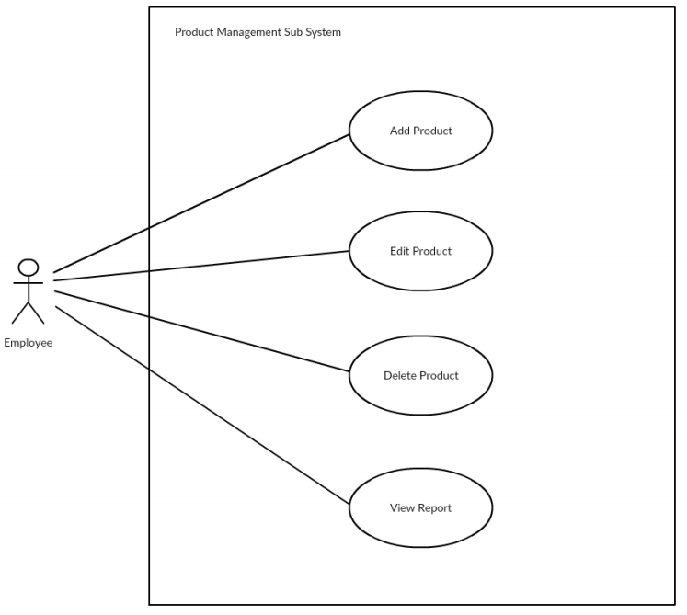

**Class Diagram**

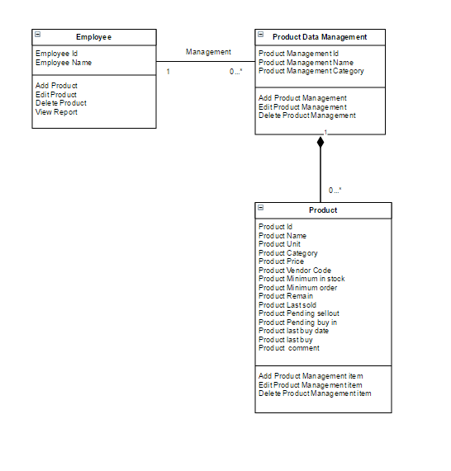

**Sequence Diagram demonstrating operation “Add product”**

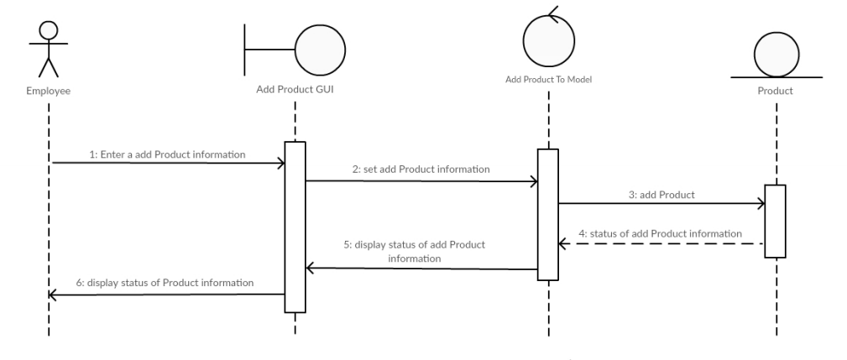

**Sequence Diagram demonstrating operation “Edit product”**

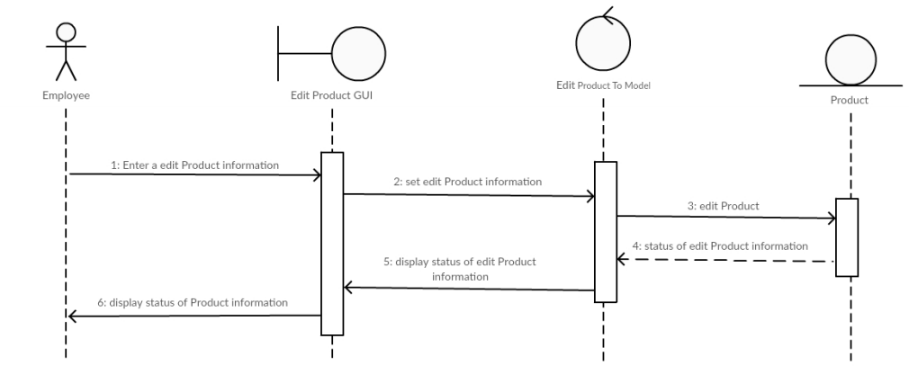

**Sequence Diagram demonstrating operation “Delete product”**

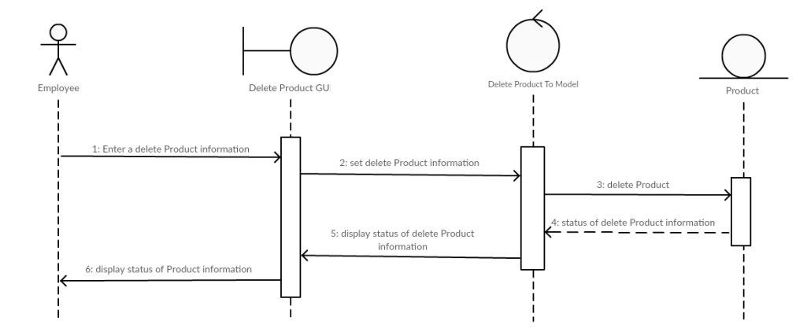

**Sequence Diagram demonstrating operation “View Report”**

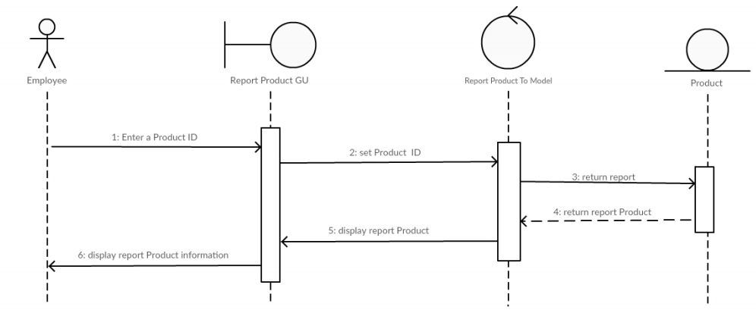

**Model-View-Controller (MVC) Model “Add Product”**

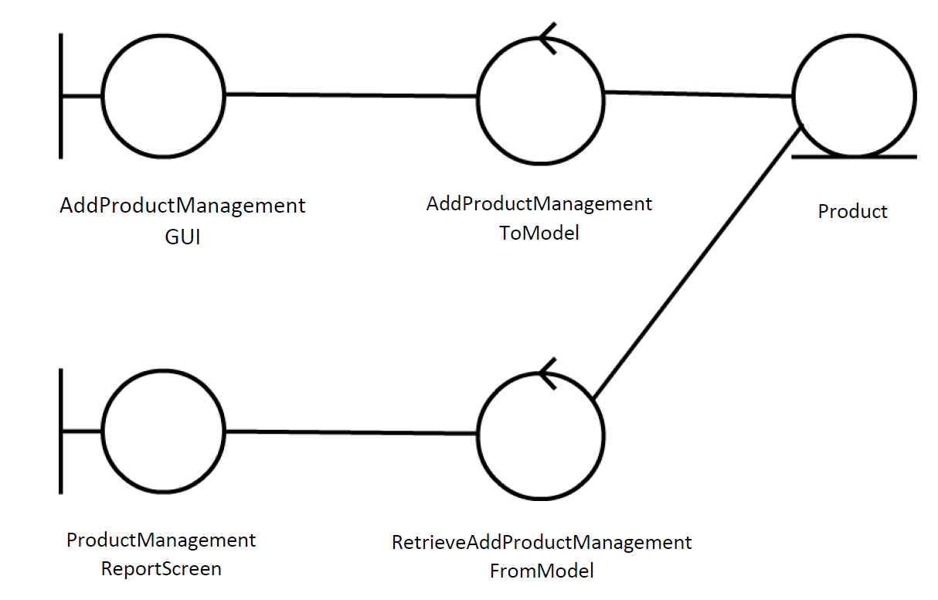

**Model-View-Controller (MVC) Model “Edit Product”**

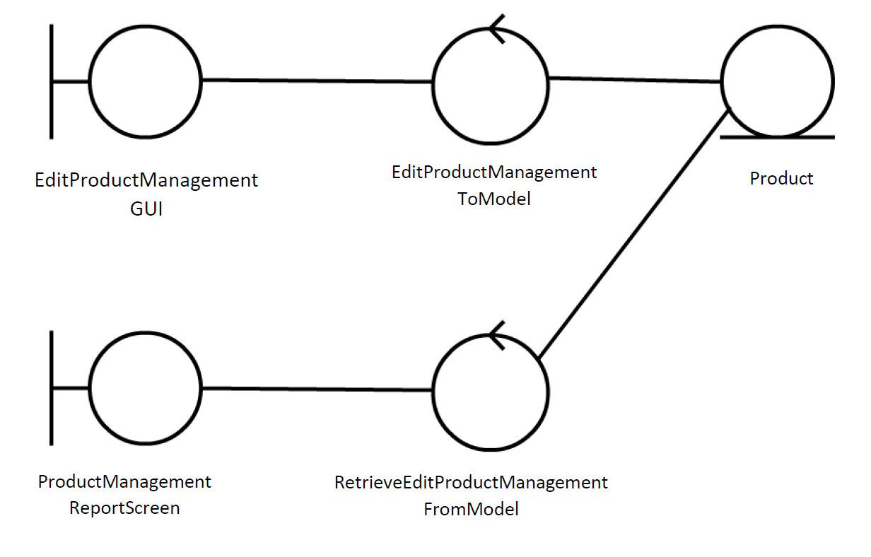

**Model-View-Controller (MVC) Model “Delete Product”**

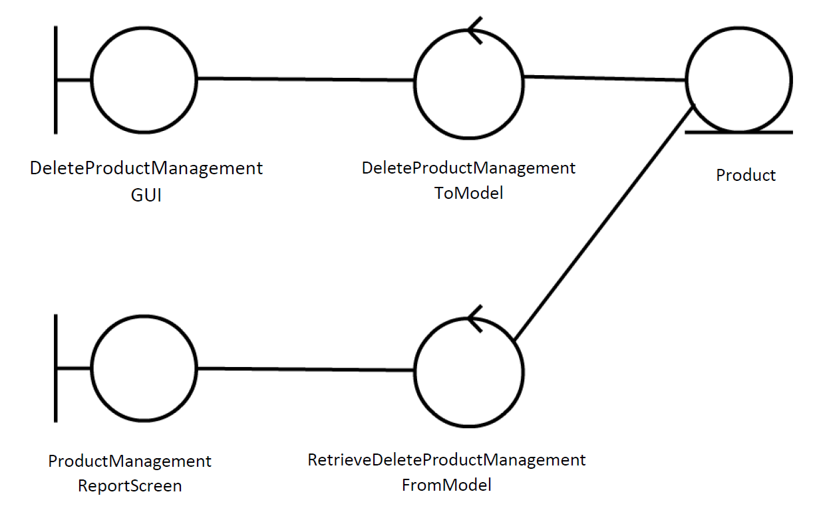

**Model-View-Controller (MVC) Model “View Report”**

